ASSIGNMENT 13

Que 1.create a union of two queries that shows the names,cities and ratings of all customers .those with rating of 200 or greater will also have words “high rating” while the others will the words “low rating”.
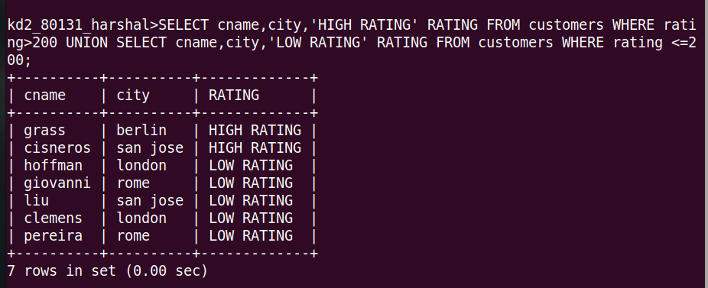

Que 2. Write a command that produces the name and number of each salespeople and each customer more than one current order put the results in alphabetical order
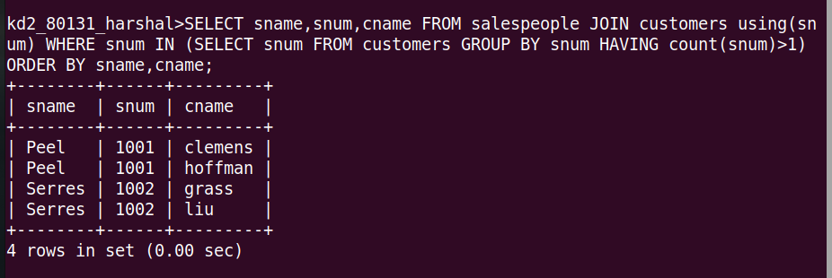
Que 3.from a union of three queries have the first select the snums of all salespeople in san jose the second the cnums of all customers in san jose and the third the onums of all orders on october 3. ratain duplictes between the last two queries but eliminates any redundancies between either of them and the first

